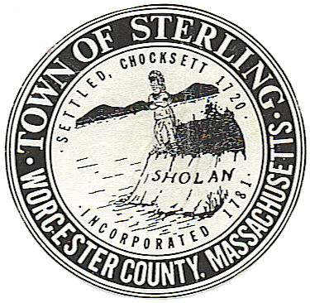
Town of Sterling
Office of the Town Clerk
One Park St, Butterick Municipal Bldg.
Sterling, Massachusetts 01564
Tel 978-422-8111 ext 2307 or 2308

NOTICE

ATTENTION: Fionuala Dullea, Co-Chair, Democratic Town Committee
Patricia Ward, Co-Chair, Democratic Town Committee

Loret Schur, Republican Town Committee

Interested voters in the Town of Sterling

On Friday October 28th, at 9:00 AM, the Sterling Town Clerk’s Office will conduct a test of the optical scan voting equipment in preparation for the State Election of
November 8, 2022, in accordance with 950 C.M.R. Section 54.02

The test will take place in Room 113,
Butterick Municipal Building, 1 Park Street, Sterling, MA.

