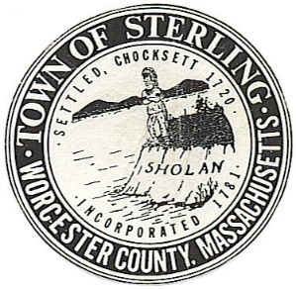
Town of Sterling
Office of the Town Clerk
One Park St, Butterick Municipal Bldg.
Sterling, Massachusetts 01564
Tel 978-422-8111 ext 2307 or 2308

NOTICE

ATTENTION: Fionuala Dullea, Co-Chair, Democratic Town Committee
Patricia Ward, Co-Chair, Democratic Town Committee
Jay Westbrook, Chair, Republican Town Committee
Interested Voters in the Town of Sterling

On Thursday, April 27, 2023, at 9:00am, the Sterling Town Clerk’s Office will conduct a test of the optical scan voting equipment in preparation for the Local Election of May 8, 2023, in accordance with
950 CMR Section 54.02.

This test will take place in Room 113 at the Butterick Municipal Building, 1 Park Street, Sterling, MA.

You are cordially invited to observe this test.

