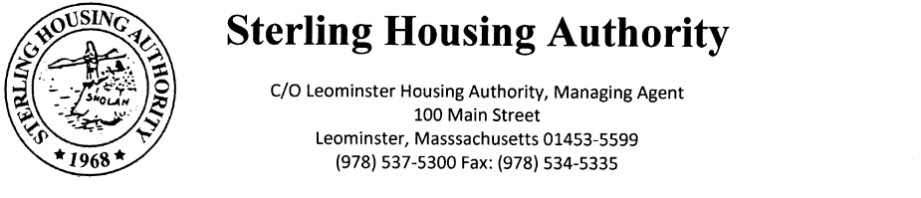
Town Clerk Received:

NOTICE OF REGULAR MEETING

Submitted by: Benjamin Gold, Executive Director 1/14/2021

The Sterling Housing Authority will meet virtually on Wednesday, January 20th at 5:30 pm. Due to social distancing guidelines related to the COVID-19 state of emergency, this meeting will be held remotely. The public is invited to call in to the meeting via phone. To do so, call
the conference line at 1-866-899-4679 and enter the Access Code 357-076-109 followed by the
# sign. The meeting will start promptly at 5:30 pm; the Board Chair will conduct the meeting. Participants will be instructed on the appropriate time and manner for public comment during
the meeting.

ITEMS TO BE DISCUSSED

- Meeting Called to Order
a. Roll Call
b. Approval of Regular Minutes of December 16, 2020
c. Opportunity for Public Comments

2. Executive Director Report
a. COVID-19 Update
b. Vaccine Update

3. Financials – December 31, 2020 year-end report will be presented at the February meeting

4. Administration
a. Modernization/Work Order Report
b. State-Aided Housing Report

5. New Business
a. Resolution 2021-1 – Approval of DHCD CFA Amendment #11 – FY24 FF Award and
Sustainability Initiative (Fish #282038)

6. Other Correspondence
DHCD Public Housing Notices 2020-40 to 2020-41

7. Resident Participation – None Requested

8. Unfinished Business: Any Items Needing Further Discussion

9. Motion to Adjourn – Next meeting scheduled for February 17, 2021

