Sterling Fair Committee Meeting Minutes
January 29th, 2024 6:30 pm to 8:00 pm in-person at the Butterick Municipal Building, or via zoom

- Call to order at 6:31 PM
- Roll call
  - Doug Downey, Megan Fowler-Magaw, David Agurkis, Maggie Agurkis, Phil Campbell, Cynthia Dodge, Mark Pruneau, Val Pruneau, Scott Handler, Amy Legere, Gloria Rugg, Bob Kneeland, Merylee Callahan, Mary Roy, Terry Heinold
  - Zoom: Carl Gronblom, Muriel Johnson
- Approval of the minutes for the last meeting
- Chairperson report
- Open issues/old business
  - Received a quote for the golf carts – 5-utility and 4-passenger. Delivered Wednesday, picked up Monday. Ask if they can pick them up Monday afternoon
  - Order ribbons /trophies from Hodges before Feb 15, get 10% discount (Muriel, Bob, Heather)
  - Scott got information from Sterling Storage Solutions for pricing of various storage options ($150-267/month)
- New business
  - Elections:
The following slate was nominated, accepted the nomination and were appropriately elected to the following positions.
    - Chairman: Doug Downey
    - Vice Chair: Mark Pruneau
    - Treasurer: Philip Campbell
    - Secretary: Megan Fowler-Magaw

Terry Heinold was thanked for his 35 years of service to the fair as an elected position. His service and dedication are truly appreciated and will be an inspiration to future elected fair committee members.

  - Inventory – we will have an inventory list available on the Google Drive that will be shared with members. If you have fair items, please let Megan know to update the inventory list
  - MAFA conference discussion: some of the topics are not applicable to us (grants, admission tickets). We did get a contact for possible livestock assistance
  - Decided on fair meetings for the rest of the year (subject to change)
Wednesday, March 6th | Wednesday, August 7th
Monday, April 1st | Monday, August 12th
Wednesday, May 1st | Wednesday, August 21st
Monday, May 20th | Monday, August 26th
Monday, June 3rd | Wednesday, September 4th (fairgrounds)
Monday, June 24th | Monday, September 23rd
Wednesday, July 10th | Wednesday, October 16th
Monday, July 22nd | Monday, November 4th

  - Drafted timeline of events for the fair as follows:
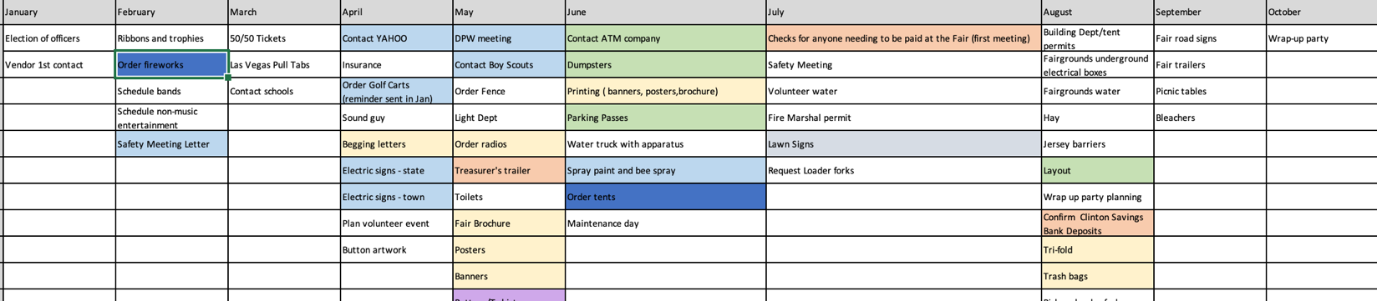
- Adjournment at 7:58 PM

